## **Objectives**

* Explain how to consume REST APIs from React applications

In this hands-on lab, you will learn how to:

* Construct a React application that invokes the REST API and fetch data from the API

## **Prerequisites**

The following is required to complete this hands-on lab:

* Node.js
* NPM
* Visual Studio Code

## **Notes**

Estimated time to complete this lab: **60 minutes.**

Create a React Application “fetchuserapp” which will retrieve the user details from <https://api.randomuser.me/> and display the title, firstname and image of a user.

Create a component named “Getuser” and in the asynchronous method “ComponentDidMount ()” invoke the URL using fetch method and the response can be displayed in the render method of the component.

Code Snippet in Getuser Component:

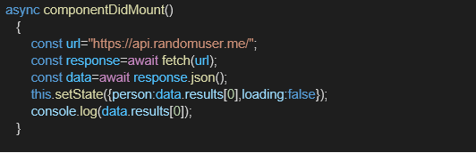

**Expected Output:**

